You have been given a brief introduction to some of the various aspects of one-point perspective drawing. Now it is time to take what you’ve learned and apply it to a finished drawing of your choice. Pick one of the following themes to develop:

- Outdoor landscape. This can center around a road, a set of train tracks, or a river. This place can be realistic or strange and unusual.
- Cityscape. Build a city scene around a street with buildings. Incorporate details like cars, people, signs, or whatever else you can think of. Where is this place? Is it realistic or imaginary?

All drawings should be worked out in pencil first, & then colored. Your finished product should include the following:

- Foreground elements: Things towards the front of the picture, which are closest to the viewer—minimum of
- Background elements: Things further away from the viewer, which will appear smaller.
- Vanishing point: Your drawing should have a single vanishing point.
- Horizon line
- At least 2 distinct textures

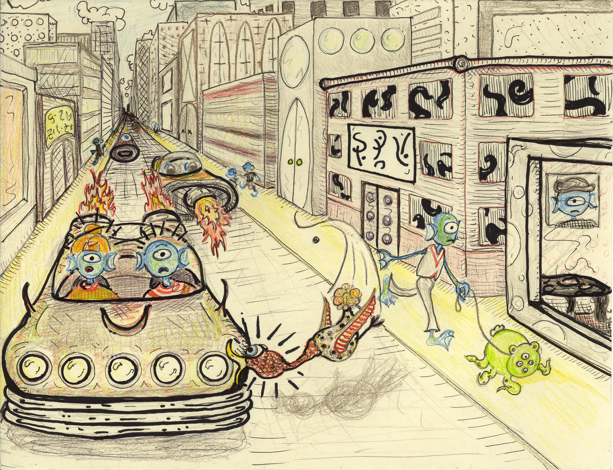

BRAINSTORMING YOUR DRAWING CHECKLIST
In your sketchbook:

- Create 2 different thumbnail drawings
- Choose 1 to work into a rough draft considering:
  - Foreground details
  - Background details
  - Eye level (where you will place horizon line)
  - Textures you will use

YOUR FINAL DRAWING SHOULD:

- Use the principles of 1-point perspective
- Be sketched out entirely in pencil, and then approved before coloring
- Have lots of detail!
- Be colored in colored pencil
- Be outlined in pen, sharpie, or colored pencil
- Be neatly and carefully crafted

Perspective Drawing Rubric:
 | 35 points | 40 points | 44 points | 47 points | 50 points
UNDERSTANDING | Minimal understanding of concepts. Many requirements and/or steps are missing. | Partial understanding of concepts. Some requirements and/or steps may be missing. | Good understanding of concepts. Most requirements & steps have been followed | Good understanding of concepts. Nearly all requirements & steps have been followed. | Thorough understanding of concepts. No flaws in use of perspective. Challenging choice of subject matter.
CRAFTSMANSHIP & DETAIL | Little attention to detail. Major flaw/flaws in craftsmanship. | Moderate attention to detail. Some flaws in craftsmanship. | Fair attention to detail. Minor flaws in craftsmanship. | Good attention to detail. Minor, or no flaws in craftsmanship. | Superior attention to detail. Meticulously drawn, outlined, and colored. Many details.

