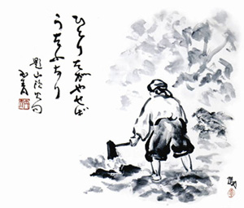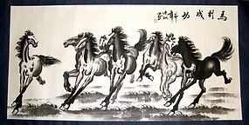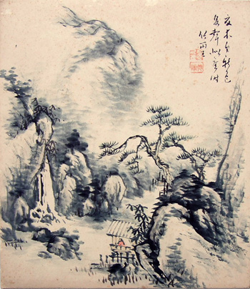

THESE ARE THE REQUIRED ELEMENTS FOR YOUR PAINTING:

1. At least one figure, human or animal (no stick figures!)
2. A background with details
3. At least one **kanji** which is appropriate to the scene
4. Incorporate at least two of the following four brush techniques:

* Dry Brush
* Wet in wet
* Wash
* Graded Wash

FOLLOW THESE STEPS WHEN CREATING YOUR SUMI-E INK PAINTING:

1. Do at least four thumbnail sketches in your sketchbook.
2. Pick your favorite idea and do a final, more detailed sketch in your sketchbook.
3. Use your laptop to find source images if necessary.
4. Use the brush and ink to create your final painting-make sure to incorporate

all necessary elements.

1. Sign your painting with your Chop!

PICK ONE OF THE FOLLOWING TYPICAL SUBJECTS

FOR YOUR SUMI-E PAINTING:

1. A Nature Scene
2. A Scene from Everyday Life
3. A Mythical Scene

SUMI-E PAINTING